TITLE OF THE PAPER: CENTERED, UPPERCASE, 14 POINT TIMES NEW ROMAN, ON SECOND LINE FROM THE TOP MARGIN, NOT MORE THAN 3 LINES LONG

Author A and Author B∗
Name of Institute
Corresponding Address
A@institute.gov; B@institute.gov

Double space and list Author C
Department of Nuclear Engineering
Name of University
Address
c@name.univ.edu

ABSTRACT
The ABSTRACT requires a brief and clear description of the present work, including the background, motivation, objective, technical methodologies and observations. The abstract should be limited to be about 200-250 words, in only one single page. Use 10 point Times New Roman here and single (10 point) spacing.

Keywords: AT MOST FIVE KEYWORDS IN UPPERCASE FORMAT

INTRODUCTION
Paper starts here with one blank line before first section title. 0.5 blank line before and after each subsequent section’s title. Section titles have style “Heading 1”, are 12 point font, must be all uppercase and centered, and must be numbered in Arabic numerals as shown above. Introduce the topic of your work in this section.
Do not indent the first line of a paragraph; rather double-space between paragraphs. There are four types of reference styles: journal paper [1], proceeding paper [2], book [3], and website [4]. References to websites are discouraged, but acceptable if absolutely necessary. It is the author’s responsibility to check links in the pdf file.
Since the paper will be included as a .pdf file for the proceedings, the author will get the best results from Word or WordPerfect by using the Acrobat Distiller or Acrobat PDFWriter as the default printer. When creating the PDF version, check the “Embed All Fonts” option. Note that it is the author’s responsibility to review the final PDF version of the paper to ensure proper translation into PDF. Final PDF file size should be no more than 4 MB. Recommended paper length is 10-12 pages.

SECOND OR SUBSEQUENT MAJOR HEADING
A logical division of your paper into sections, etc., makes it so much easier to understand. The style for subsection titles and all text in this template is “Heading 2,” “Heading 3,” etc. All text in this template is “Body Text 3.” Make sure to avoid widow/orphan lines.

2.1. Subsection Title: First Character of Each Non-trivial Word is Uppercase
Double-space before and after secondary titles. Secondary titles should start flush left, and are numbered as illustrated above.
Equations should be centered and sequentially numbered to the flush right of the formula. 0.5 blank line before and after the equations.
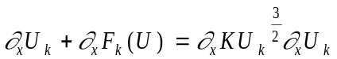 (1)
The continuation of a paragraph after an equation is not indented. All paragraphs, as well as section or subsection headings, are separated by just one single empty line.

2.1.1. Sub-subsection level and lower: only first character uppercase
Figures and tables should appear as closely as possible to where they are first cited, e.g. Fig. 1, in the text. Figures are numbered in Arabic numerals, with the caption centered below the figure, in boldface. Triple-space before the figure, and after the figure caption.
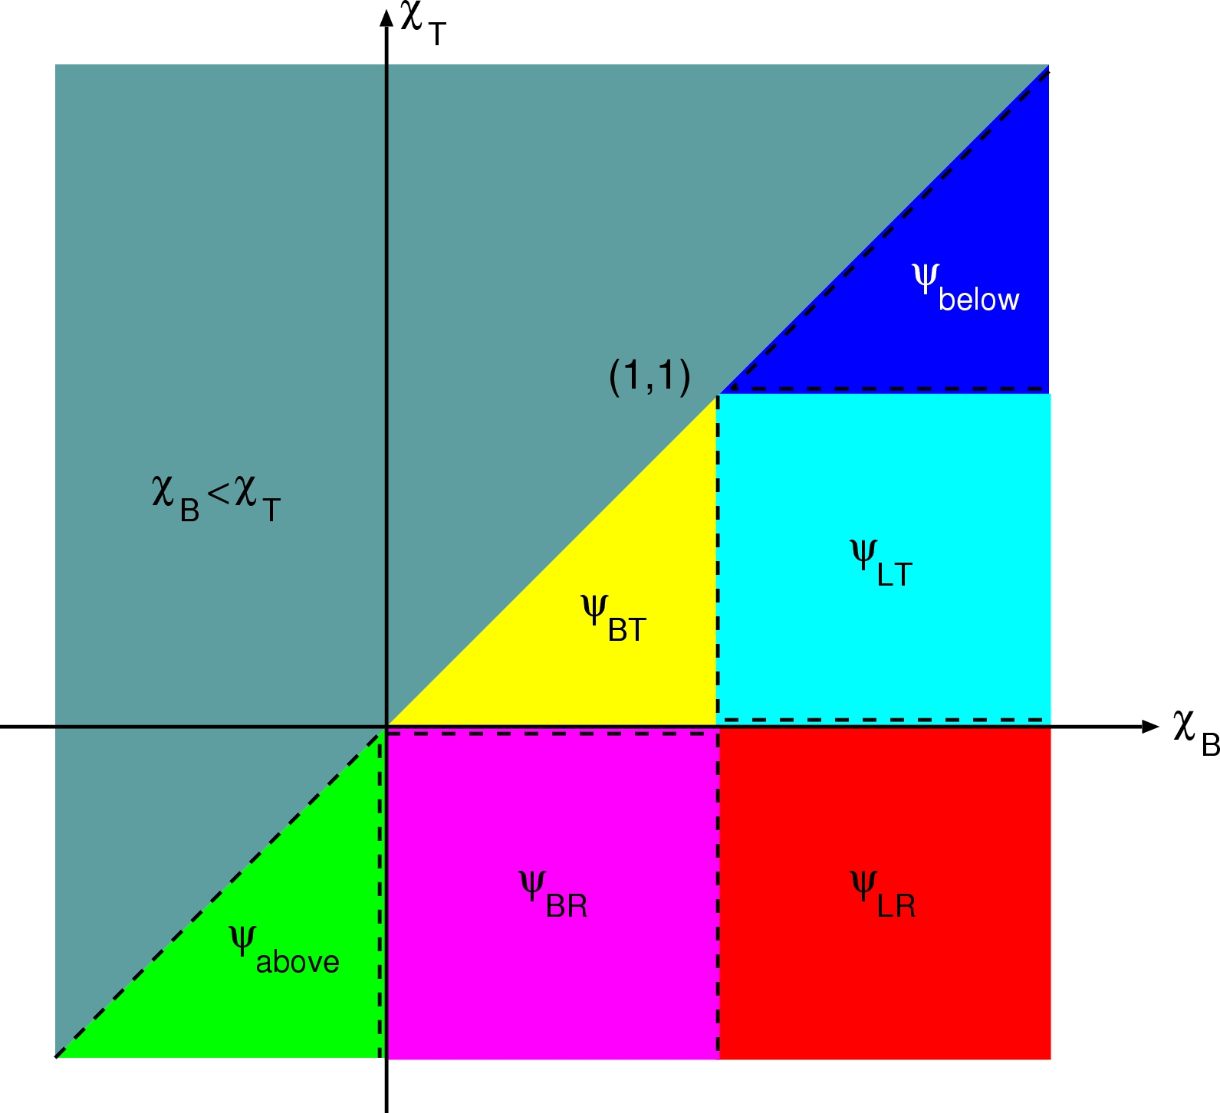
Figure 1. Sample figure.

When importing figures or any graphical image please verify two things:
- Any number, text or symbol is in Times font and is not smaller than 10-point after reduction to the actual window in your paper;
- That it can be translated into PDF.

All tables should be numbered consecutively and captioned; the caption should be centered above the table as shown in Table 1. The body of the table should be no smaller than 7 pt. There should be a minimum one line spaces (or 24 pt) between tables and text.
Table 1: An example table.
Mesh | 8 x 8 | 16 x 16 | 32 x 32 | 64 x 64
Nodal | 1.000x10⁻¹ | 2.500x10⁻² | 6.250x10⁻³ | 1.563x10⁻³
Characteristic | 1.000x10⁻¹ | 2.500x10⁻² | 6.250x10⁻³ | 1.563x10⁻³

3. CONCLUSIONS
Present your summary and conclusions here.

ACKNOWLEDGMENTS
This template was adapted from the template for Math and Computation 2009 posted on the Internet. Acknowledge the help of colleagues, and sources of funding, if you wish.

REFERENCES
- B. Author(s), “Title,” Journal Name in Italic, Volume in Bold, pp.34-89 (20xx).
- C. D. Author(s), “Article Title,” Proceeding of Meeting in Italic, Location, Dates of Meeting, Vol. n, pp.134-156 (19xx).
- E. F. Author, Book Title in Italic, Publisher, City & Country (20xx).
- “Spallation Neutron Source: The next-generation neutron-scattering facility for the United States,” http://www.sns.gov/documentation/sns_brochure.pdf (2002).

 Footnote, if necessary, in Times New Roman font and font size 9

